**Nanoarthplus Site Wide Changes**

**Homepage Changes:**

1. **Slider** which will show up the top surgical products by any brand.
2. Under the slider there comes the **Feature Products** which will lazily load the products when a user scrolls the page. There should be at least 50 products shown and then pagination.

**Top Menu Changes:**

1. Remove the **Categories** Option from the top menu.
2. Under the **Product Menu** show 20 to 30 product links and then show a menu **browse the catalog** in the product popup menu that will takes the user to the all products page. Take this example in mind: Replace **Deals by Store** with **Products by Store** and that’s it.

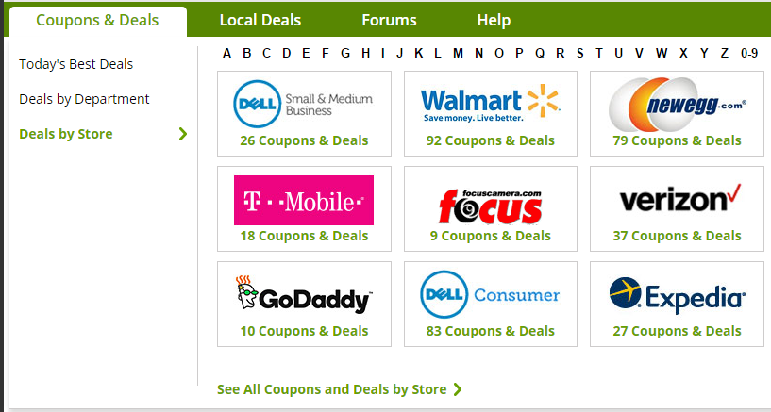

**Footer Changes:**

Make footer like this one;

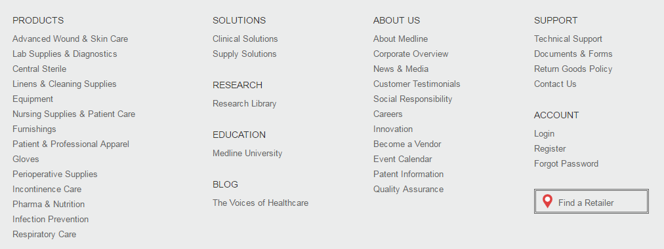

1. Replace the **Nanoarthplus Section** with the **Products**.
2. Replace the **User Navigation Section** with the **Support Section & Account**.
3. And leave the **Newsletter Section** as it is. No changes at all.